Flu Vaccination

CAMPAIGN SPONSOR: American Medical Association (AMA), Centers for Disease Control and Prevention (CDC)
VOLUNTEER ADVERTISING AGENCY: Adolescent

CAMPAIGN OVERVIEW:
CDC estimates that as many as 41 million Americans get sick from the flu each season, resulting in hundreds of thousands of hospitalizations and up to 50,000 deaths. Longstanding inequities that put undue burden and barriers on Black and Hispanic communities have resulted in flu shot coverage disparities. During the 2021-2022 flu season, flu vaccination coverage was 12% lower in Black adults and 16% lower in Hispanic adults compared to white adults.
A seasonal flu shot is the best way to help protect yourself and those around you against the flu. Flu shots have many benefits including reducing the risk of flu illnesses, hospitalizations, and flu-related deaths. The flu shot reduces your risk of getting the flu, and if you do happen to get the flu, it’s likely to be less severe. The benefits of flu shots are particularly important this year, given the potential repeat “triple-demic” of respiratory illnesses: COVID-19, RSV, and flu. This could further strain an already overwhelmed health system, challenging our ability to provide care to all patients.

CAMPAIGN OBJECTIVE:
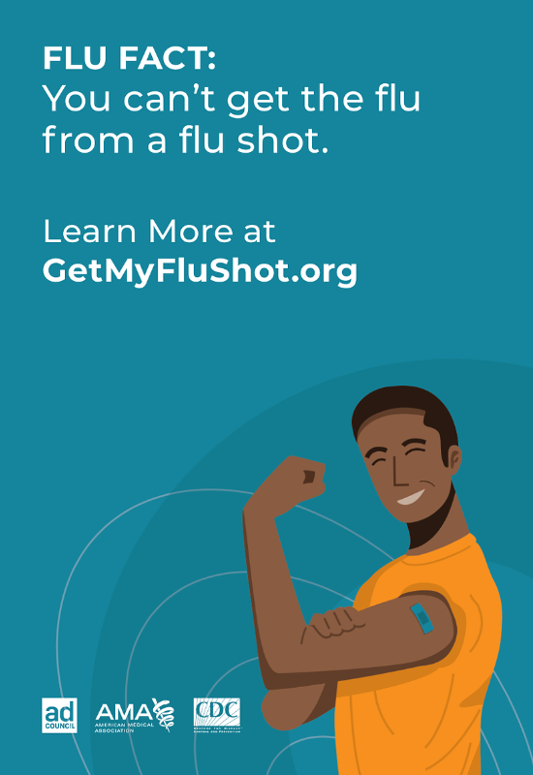
The campaign encourages the American public, with an emphasis on Black and Hispanic audiences, to get vaccinated against the flu for the 2023-24 flu season.

CAMPAIGN DESCRIPTION:
Striking a more serious and urgent tone, new creative features real doctors answering some of the most common and important questions about flu shots. The “Flu Facts” creative presents straightforward information and conveys the importance of getting a flu shot to protect yourself and your community. The campaign will complement creative from recent years including “No Time for Flu” and “#FluFOMO.” These assets are inspired by the insight that people are motivated by caring for their loved ones and are juggling more responsibilities than ever. Audiences are directed to GetMyFluShot.org for more information, including where to get a flu shot in their area.

TARGET AUDIENCE:
General public with an emphasis on Black and Hispanic adults.

CALL TO ACTION: Get a flu shot for yourself and those around you.

